**LTE and 5G Handover Protocols: An evaluation and comparison**

Tomasz Przybylski  
CI6250

# *Abstract –*

This paper aims to have a look at the existing LTE X2 handover protocol and some proposed 5G handover protocols. The comparison between these handover protocols will be then interpreted into Quality of Service and Quality of Experience metrics and presented in the conclusion of this paper.

# *Introduction –*

What is 5G? That is a question that is asked by consumers and researchers alike. “5G is an evolution considered to be the convergence of Internet services with legacy mobile networking standards leading to what is commonly referred to as the ‘mobile Internet’ over Heterogeneous Networks” [Introduction, Fundamentals of 5G Mobile Networks, Rodriguez, J et. al. 2015]. “A heterogeneous network is a network for which an area is covered simultaneously by cells of different sizes (macro-cell, micro-cell, pico-cell, femto-cell)” [Synchronization Principles p229-240, André Perez 2017]. The new generation of mobile and telephony communication, proposed as “5G”, promises to significantly increase individual user throughput by a factor of 20 as well as a 10x increase to the capacity of users on networks. It aims to do this by increasing the frequency bands up to a maximum of 80-90GHz. This is a necessary step as the number of users on the Internet surpassed 4.5 billion in June 2019 [https://www.internetworldstats.com/stats.htm 2019 Accessed on: 26/11/2019] and the expected annual data rate will surpass 3.3 Zettabytes in 2021, an increase of 175% from 1.2 Zettabytes in 2016 [CISCO Global 2021 Forecast Highlights, 2016. Cisco and/or its affiliates]. With the introduction of new ideas such as the Internet of Things (IoT), Internet of Everything (IoE) and Device to Device communications, not only will the number of devices and the amount of data transmitted increase, but the number of connections between devices will rise dramatically. That is why it is imperative to re-evaluate existing concepts.

This paper aims to look at the difference in handover between the X2 Based handover protocol of LTE, and some proposed handovers of 5G.

# *Literature Review –*

With the emergence of 5G, a number of previously established protocols must be re-evaluated. One area of research is handover procedure. Current LTE standards for handover protocols, such as the UE X2 & S1 Handover protocols, stand to benefit from the increased research into 5G and SBS as the need for more frequent and more efficient handover protocols becomes more apparent.

During the movement of User Equipment (UE), the handover protocol is constantly active. Depending on the device, telecommunication technology, service provider and geographical location, the protocols and their details may vary. The most widespread LTE handover standard is the UE X2 handover protocol.

eNB

eNB

eNB

MME  
S-GW / P-GW

MME  
S-GW / P-GW

*eNB = Evolved Node B (Base Station) MME = Mobility Management Entity  
S-GW = Serving Gateway P-GW = PDN (Packet Data Network) Gateway*

As the UE moves away from the Source eNB(S-eNB) it is currently connected to, the handover protocols determine which Target eNB(T-eNB) to connect to. There are 2 different types of handovers:  
Hard Handover: Also known as a break-before-make connection. The connection between the S-eNB + MME and the UE is temporarily broken before being instantaneously remade with the closer T-eNB. This is usually the case in FDMA (Frequency Division Multiple Access) and TDMA (Time Division Multiple Access) based systems. As LTE and 5G are less reliant on FDMA and TDMA, this type of handover is very rarely if ever used.  
Soft Handover: Also known as a make-before-break connection. A connection is established to other eNBs as the UE gets within range. When the handover protocol determines that it would be advantageous to change from the S-eNB to a T-eNB, the old connection is terminated and the handover is complete.

There are also several subtypes of handovers, including:  
Intra-eNB – This means handovers between different eNBs while maintaining the connection to the same MME and S-GW/P-GW. The handover involving the X2 interface is an example of Intra-eNB handover.  
Inter-eNB – This means a handover between a S-eNB and a T-eNB that are connected to different MMEs. This can involve also changing S-GWs, however that is not entirely necessary in some cases. The S1 based handover is an example of this type of handover.

As mentioned earlier, one of the most common handover protocols involves the use of the X2 interface to perform Intra-eNB handovers. The X2 interface consists of the following components that facilitate a handover:  
X2-AP (Application Protocol) [ETSI TS136.423 V12.5.0 2014] – This protocol provides application layer support for the X2 interface to perform the following:   
-Mobility Management (i.e. the Handover Protocol)   
-Load Management – Indication of resources, overload, traffic load statuses  
-Reporting of General Error Situations  
-Setting and Resetting of the X2  
-eNB Configuration Updates – Making sure two eNBs have interoperable X2 interfaces  
-Mobility Parameter Management – Enables coordination of mobility parameter settings  
-Mobility Robustness Optimisation – Allows for feedback related to mobility failure events  
-Energy Efficiency – Energy consumption optimisation options   
-X2 Release – Enables an eNB to be aware of signal unavailability   
-Message Transfer – Indirect transport of X2AP messages between eNBs  
-Registration – Registration of eNB to allow support for Message Transfer  
-Removing X2

X2-CP (Control Plane) [X2 interfaces Function in LTE – A connection between two eNodeBs <http://teletopix.org/4g-lte/x2-interface-function-in-lte-a-connection-between-two-enodebs/> Accessed on: 28.11.2019] – This is the transport layer protocol of X2 that uses the Stream Control Transmission Protocol IP (SCTP IP [RFC 4960 & RFC 8540]) to manage and exchange overloads and traffic loads and corresponding information between eNBs to increase the efficiency of traffic load handling. It also enables the establishment and release of tunnels between S-eNBs and T-eNBs during a handover operation. The full list of functions is as follows:  
-Intra mobility support for UE  
-Context transfer from S-eNBs to T-eNBs  
-Control X2-UP tunnels between S-eNBs and T-eNBs  
-Handover cancellation  
-Uplink load management   
-X2 general management  
-Error handling

X2-UP (User Plane) – This protocol, located on the Radio Network layer, tunnels and identifies end-user packets travelling between eNBs and manages potential packet loss. This protocol is used for conveying control information related to data flow management.

Below is an example of how an X2 Intra-eNB handover process would look (Data interpreted from [Event Helix Handover Sequence http://www.eventhelix.com/lte/handover/x2/lte-x2-handover-sequence-diagram.htm Accessed on: 28.11.2019]:

|  |  |  |  |  |  |
| --- | --- | --- | --- | --- | --- |
| UE | T-eNB | S-eNB | MME | SGW + PGW | Explanation |
|  |  |  |  |  | RRC Measurement Control & Report |
|  |  |  |  |  | X2AP Handover Request |
|  |  |  |  |  | X2AP Handover Request Acknowledgement |
|  |  |  |  |  | X2 Bearer channel establishment |
|  |  |  |  |  | RRC Connection Reconfiguration Request |
|  |  |  |  |  | X2AP SN Transfer Status |
|  |  |  |  |  | Downlink Data during Handover Preparation |
|  |  |  |  |  | Uplink Data during Handover Preparation |
|  |  |  |  |  | Begin Switching to T-eNB |
|  |  |  |  |  | RRC RACH Preamble |
|  |  |  |  |  | Random Access Response |
|  |  |  |  |  | RRC Connection Reconfiguration Complete |
|  |  |  |  |  | End Switching to T-eNB |
|  |  |  |  |  | Queued Downlink Data downloaded from T-eNB |
|  |  |  |  |  | S1AP Path Switch Request |
|  |  |  |  |  | S11 GTP-C Update Bearer Request |
|  |  |  |  |  | S11 GTP-C Update Bearer Response |
|  |  |  |  |  | S1AP Path Switch Request Acknowledgement |
|  |  |  |  |  | X2UE Context Release |

Figure 2 depicts the same event as the table above [Analyzing X2 Handover in LTE/LTE-A, Alexandris Konstantinos et. al.]–––––  
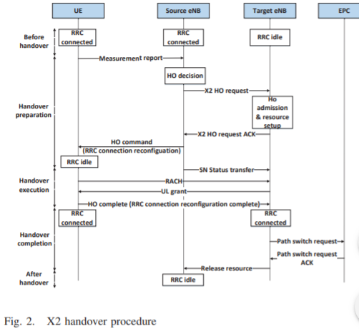

During a mobility event that leads to a handover, the RSRP (Reference Signal Receive Power) of the T-eNB must be larger than RSRP of the S-eNB combined with the A3Offset + A3Hysteresis – CellIndividualOffsetEUTRAN   
(RSRT>RSRS+A3Offset+A3Hysteresis-CellIndividualOffsetEUTRAN)  
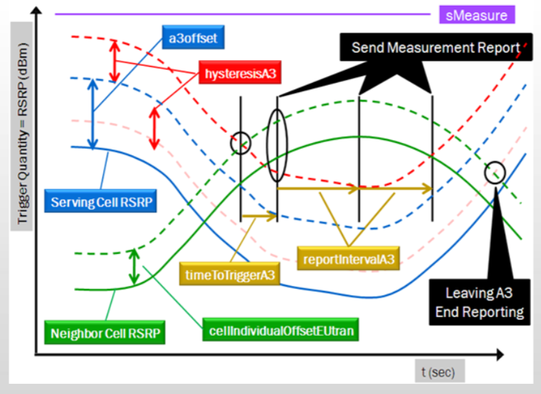  
A3Offset [3GPP 36.331] - The role of this offset is to make the S-eNB look better than its current measurement in comparison to the neighbour, to provide more robust handovers. [Rodriguez, J 4G Seminar p75]  
A3Hysteresis – The role of the hysteresis is to make the measured neighbour look worse than measured to ensure it is much stronger before the UE decides to send a measurement report to initiate a handover. [Rodriguez, J 4G Seminar p75]  
TimeToTriggerA3 – This is to avoid a ping-pong effect (At expiration, if the UE does not receive an RRC connection reconfiguration message, another timer is started (ReportingIntervalA3). If this timer expires, the measurements are repeated and transmitted again. If a number of retransmissions occur (ReportingAmount) without a response, the process is cancelled.  
CellIndividualOffsetEUTRAN – The higher this value, the “more attractive” the eNB will look to the UE.

For 5G, there are several proposed handover types, some of these include:  
UE Initiated Handover and Network Initiated Handover (as per specifications published from Verizon 5G Technical Forum document TS V5G.300.) These are not unlike the X2 LTE handover described above.  
Another type is a Request-Based Handover Strategy Using NDN for 5G proposed by Fan Jia and Xialoin Zheng [Wireless Communications and Mobile Computing Volume 2018, Article ID 4513070]. This protocol uses a Request-Based Handover Strategy (RBHS) that promises around 30% higher cache hit rate and 20% more traffic reduction compared to Signal-to-Interference-plus-Noise-Ratio (SINR) of previous handover types.  
Yet another proposed handover is the mmHandover, which would be a pre-connection-based handover protocol for 5g millimetre wave vehicular networks [Xiong Wang, Linghe Kong, Jintao Wu et.al. 2019]. mmHandover aims to alleviate the problems occurring with frequent handover changes and signal blockages by providing a real-time handover protocol.  
Lastly, A Flat Mobile Core Network for Evolved Packet Core Based SAE Mobile Networks [Mohammad Al Shinwan, Trong-Dinh Huy, Kim Chul-Soo, Journal of Computer and Communications, 2017, 5, 62-73] proposes to combine the P-GW and S-GW into a “Cellular Gateway” (C-GW), increase the distribution of these C-GW in a mobile core network, and to increase MME functionality to include centralizing mobility anchor and allocation of IP addresses for UEs.

# *Scenario Definition –*

The focus of this scenario will be the Received Signal Strength-based TTT Window algorithm for LTE-A systems outlined in Optimized Performance Evaluation of LTE Hard Handover Algorithm with Average RSRP Constraint [Cheng-Chung Lin et.al. International Journal of Wireless & Mobile Networks (IJWMN) Vol.3, No.2, April 2011 p.4]

## Received Signal Strength-based TTT Window Algorithm Parameters

|  |  |  |
| --- | --- | --- |
| Parameter Explanation | Parameter | Value(s) |
| Reference Signal-Received Power | RSRPT & RSRPs (dBm) | [-44 to -140] |
| RSRP with Threshold and Handover Margin | HOM (dB) | [-5 to 15] |
| Time-To-Trigger | TTT (ms) | 40 |
| HandOver Trigger | HOTrigger | 10 |
| Received Signal Strength | RSS | Same as RSRP |
| Handover measurement period | Tm |  |
| Integer multiple of Tm | Tu | (x)Tm |
| “Forgetting Factor” | Β (or B) | Tu/Tm = 2 |
|  |  |  |

RSRPT>RSRPS+HOM  
RSS(nTm)= βRSS(nTm)+(1- β)RSS((n-1)Tm)  
β=Tu/TmRSS(nTm)T>=RSS(nTu)S + HOM

# *Simulations –*

# *Results –*

# *Conclusions –*